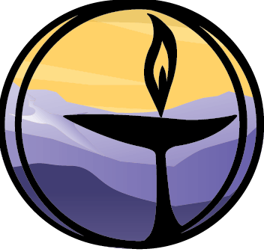
Interdependence (Soul Matters Edition)
Covenant Group Session Plan
Greenville Unitarian Universalist Fellowship, Greenville, South Carolina
Based on material from Soul Matters-Small Group: The Gift of Interdependence April 2024
Compiled and adapted by Denise Frick, April 2024

Welcome, Chalice Lighting: Here we are, together in this space. By our love and by our covenant, we make this a holy place. We light the chalice of Unitarian Universalism in honor of the light that lives in each of us, the light that shines among us, and the light we bring into the world.

Personal Check In: Briefly share something from your life since we last met and how you are feeling now.
Opening Words:
Talk of interdependence immediately calls up the work of saving the planet, rightly so. But what if the first step toward saving the planet is learning to speak to it? And hear it? Could our collective failure to confront the climate crisis be rooted in our lost ability to listen? What if the quickly-going-extinct creatures don’t want our sympathy, but our ear? What if the fraying of the web isn’t just about us failing to act, but also us having forgotten who we are. And what if nature itself is the only one who can help us remember?
~ Soul Matters Introduction to the Gift of Interdependence
Questions to prompt and guide discussion:
- What aspect of nature did you connect with most meaningfully as a child? A dog? A horse? A tree? The ocean? Lightning bugs? The rain? A path in the woods? Share an experience.
- How has the passage of time passage of time or the wisdom that comes from experience impacted the way you care for or connect with the interdependent web?
- Where do you feel your connection to nature in your body? What happens to you when that place of connection is stirred? What has that feeling of connection communicated to you most recently?
- When was the last time you became thoroughly absorbed in the curiosity of understanding another creature's life? Share that experience.
- Has a tree ever spoken to you? How about a river? Or the ocean? Or the moon? What about a weed? Explain.
- Some of us live in a place and others of us belong to a place. Describe the place where you belong.

Readings – see below
Sharing - This is a time to speak without interruption and for deep listening. Deep listening means no interrupting, no fixing, no saving, no advising, and no setting each other straight. Please share one or more responses to the session questions or the readings.
(After each person has shared, this can be a good time to take a brief break)
Open Discussion - This is a time to respond to something another person said about the topic or to relate additional thoughts that may have occurred as others shared their thoughts on this topic. Continue to practice deep listening.

Closing reading:
We never know how our small activities will affect others through the invisible fabric of our connectedness. In this exquisitely connected world, it's never a question of 'critical mass.' It's always about critical connections.
~Grace Lee Boggs, Chinese American activist, and philosopher

Announcements / Plans

Personal Check Out: As we leave today, how are you feeling now? Also, please share any comments you have on how our circle process is going.
Extinguish the Chalice We extinguish this flame but not the light of truth, the warmth of community, or the fire of commitment. These we carry in our hearts until we are together again.

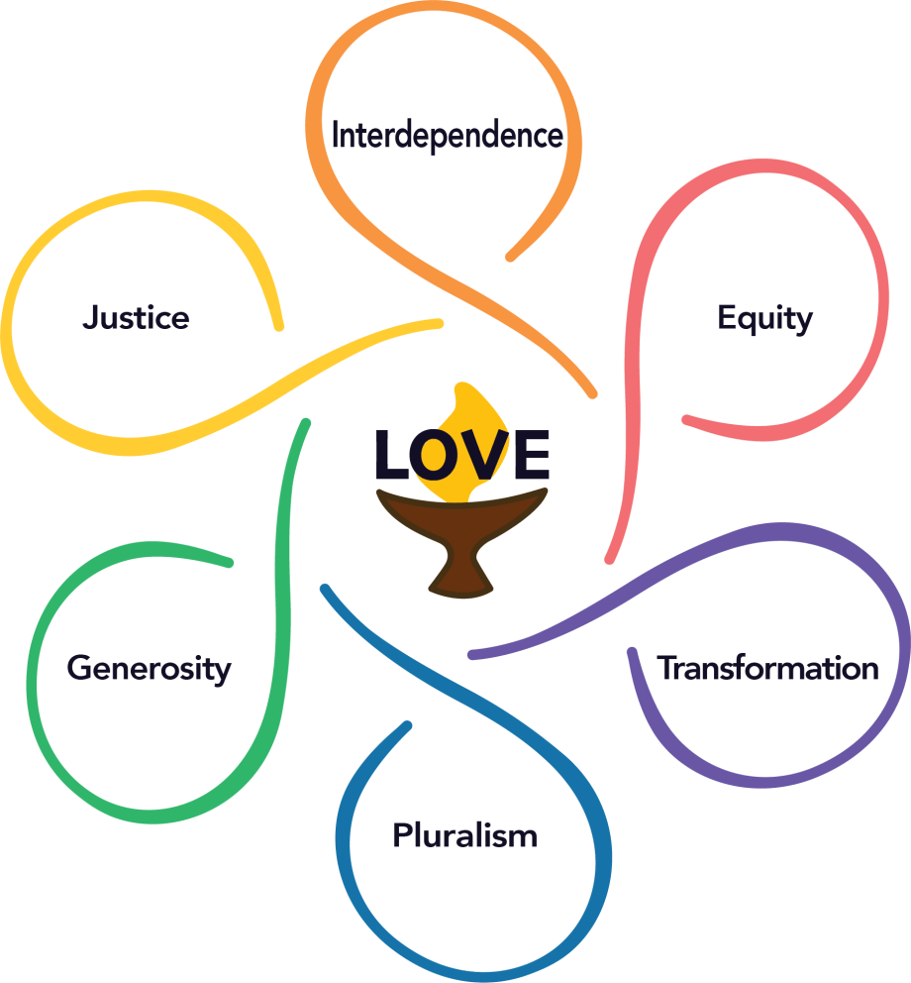
Readings

Interdependence
We honor the interdependent web of all existence. With reverence for the great web of life and with humility, we acknowledge our place in it.
We covenant to protect Earth and all beings from exploitation. We will create and nurture sustainable relationships of care and respect, mutuality and justice. We will work to repair harm and damaged relationships.
~from Article II Purpose and Covenant Proposal, UUA, https://www.uua.org/uuagovernance/committees/article-ii-study-commission/final-proposed-revision-article-ii

Douglas Steere, a Quaker teacher, says that the ancient question, “Who am I?” inevitably leads to a deeper one, “Whose am I?” – because there is no identity outside of relationship. You can’t be a person by yourself. To ask “Whose am I?” is to extend the question far beyond the little self-absorbed self, and wonder, Who needs you? Who loves you? To whom are you accountable? To whom do you answer? Whose life is altered by your choices? With whose life, whose lives, is your own all bound up, inextricably, in obvious or invisible ways?
~Victoria Stafford, UU minister

Each friend represents a world in us, a world possibly not born until they arrive, and it is only by this meeting that a new world is born. ~Anais Nin, French born American writer

We are all broken by something. We have all hurt someone and have been hurt... The ways in which I have been hurt—and have hurt others—are different from the ways [others have] suffered and caused suffering. But our shared brokenness connects us. ~Bryan Stevenson, American lawyer, and social activist

In the Blackfoot tribe, when people meet, they don’t say “How are you” but “Tza Nee Da Bee Wah?” which means, “How are the connections?” If the connections are in place, we must be all right. If the connections are not in place, then we need to tend them first. ~ Mark Nepo, American poet and spiritual advisor

Much as I enjoy popular New Age commentary on love, I am often struck by the dangerous narcissism fostered by spiritual rhetoric that pays so much attention to individual self-improvement and so little to the practice of love within the context of community. Packaged as a commodity, spirituality becomes no different from an exercise program. While it may lead to the consumer feeling better about his or her life, its power to enhance our communion with ourselves and others in a sustained way is inhibited. ~bell hooks, American writer and social critic

I wish the knowledge were easier to come by, that individualism is just a scam, that you are always the butterfly wings. You are always a flap of the storm…
You must not believe the lying lie that you do not matter, that whatever change you can organize is so insufficient as to not be worth your time… ~Rev. Julián Jamaica Soto, UU Minister and activist

Land is not capital to which we have property rights; rather it is the place for which we have moral responsibility in reciprocity for its gift of life. Here is the question we must at last confront: Is land merely a source of belongings, or is it the source of our most profound sense of belonging? We can choose… You, right now, can choose to set aside the mindset of the colonizer and become native to place, you can choose to belong.
~Robin Wall Kimmerer, Potawatomi botanist & author.

Whether we and our politicians know it or not, Nature is party to all our deals and decisions, and she has more votes, a longer memory, and a sterner sense of justice than we do. ~Wendell Berry, American writer, and environmental activist

You carry Mother Earth within you. She is not outside of you. Mother Earth is not just your environment. In that insight of inter-being, it is possible to have real communication with the Earth, which is the highest form of prayer.
~Thich Nhat Hanh, Vietnamese Buddhist monk

How monotonous our speaking becomes when we speak only to ourselves! And how insulting to the other beings – to foraging black bears and twisted old cypresses – that no longer sense us talking to them, but only about them… Small wonder that rivers and forests no longer compel our focus or our fierce devotion. For we walk about such entities only behind their backs, as though they were not participants in our lives. Yet if we no longer call out to the moon slipping between the clouds, or whisper to the spider setting the silken struts of her web, well, then the numerous powers of this world will no longer address us – and if they still try, we will not likely hear them.
~David Abram, American ecologist and philosopher

If you find yourself… hearing, again, the earth's great, sonorous moan that says… all you love will turn to dust… Do not raise your small voice against it… Instead, curl your toes into the grass… Walk through the garden's dormant splendor.
Say only, thank you. ~Ross Gay, American poet, essayist, professor.

And if it’s true we are alone,
we are alone together,
the way blades of grass
are alone, but exist as a field.
Sometimes I feel it,
the green fuse that ignites us,
the wild thrum that unites us…
~Rosemerry Wahtola Trommer, American poet

